Port Performance Annual Report
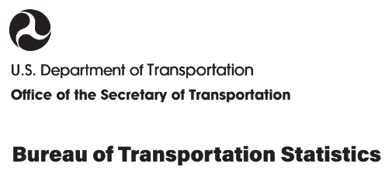
2026 Edition

About This Report
Bureau of Transportation Statistics
Rolf R. Schmitt, Acting Director, Office of Director
Publication Management Official
Ramond Robinson, Director, Office of Transportation Analysis
Project Manager
Patricia DiJoseph, PhD, Transportation Specialist, Office of Transportation Analysis
Major Contributors
Patricia DiJoseph, PhD, and Nubia Del Carpio
Editor
Mikki Stacey
Visual Information Specialists
Alpha Wingfield
Other Contributors
Miles Weule Chandler; Sean Jahanmir; Hyun Kim; Kyle Titlow; Doug McDonald; Alexis Reyes; Marin Kress, PhD; Amy Tujague

Report DOI  10.21949/z3wj-hd65 | Publication Date  January 2026 | Key Words  Port Performance; Annual Report; 2026; Freight Statistics; Waterborne Transportation
Title  Port Performance Freight Statistics: 2026 Annual Report | Performing Organization  Bureau of Transportation Statistics  1200 New Jersey Ave, SE  Washington, DC 20590
Recommended Citation
United States Department of Transportation, Bureau of Transportation Statistics. Port Performance Freight Statistics: 2026 Annual Report. Washington, DC: 2026. .

All material contained in this document is in the public domain and may be used and reprinted without special permission. Source citation is required.
BTS information service contact information:
Ask-A-Librarian http://transportation.libanswers.com/
Phone 202-366-DATA (3282)
Quality Assurance Statement
The Bureau of Transportation Statistics (BTS) provides high quality information to serve government, industry, and the public in a manner that promotes public understanding. Standards and policies are used to ensure and maximize the quality, objectivity, utility, and integrity of its information. BTS reviews quality issues on a regular basis and adjusts its programs and processes to ensure continuous quality improvement.
Notice
This document is disseminated under the sponsorship of the U.S. Department of Transportation in the interest of information exchange. The U.S. Government assumes no liability for its contents or use thereof.

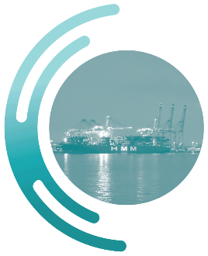
- Emerging Topics in Waterborne Transportation

  - trade through the Strait of hormuz
The Strait of Hormuz (Strait) is a critical conduit for crude oil to the United States. 18% of U.S. crude oil imports that arrived via vessel transited the Strait. The Strait is located between Iran and Oman and connects Persian Gulf ports to the rest of the world (Figure 26). Ports are in Bahrain, Iran, Iraq, Kuwait, Qatar, Saudi Arabia, and the United Arab Emirates. In June 2025, a conflict involving Iran, Israel, and the United States raised the possibility of interrupted shipping through the Strait (Brown, O'Rourke, Ratner, Rosen, & Thomas, 2025).
Figure 1. Map of the Strait of Hormuz
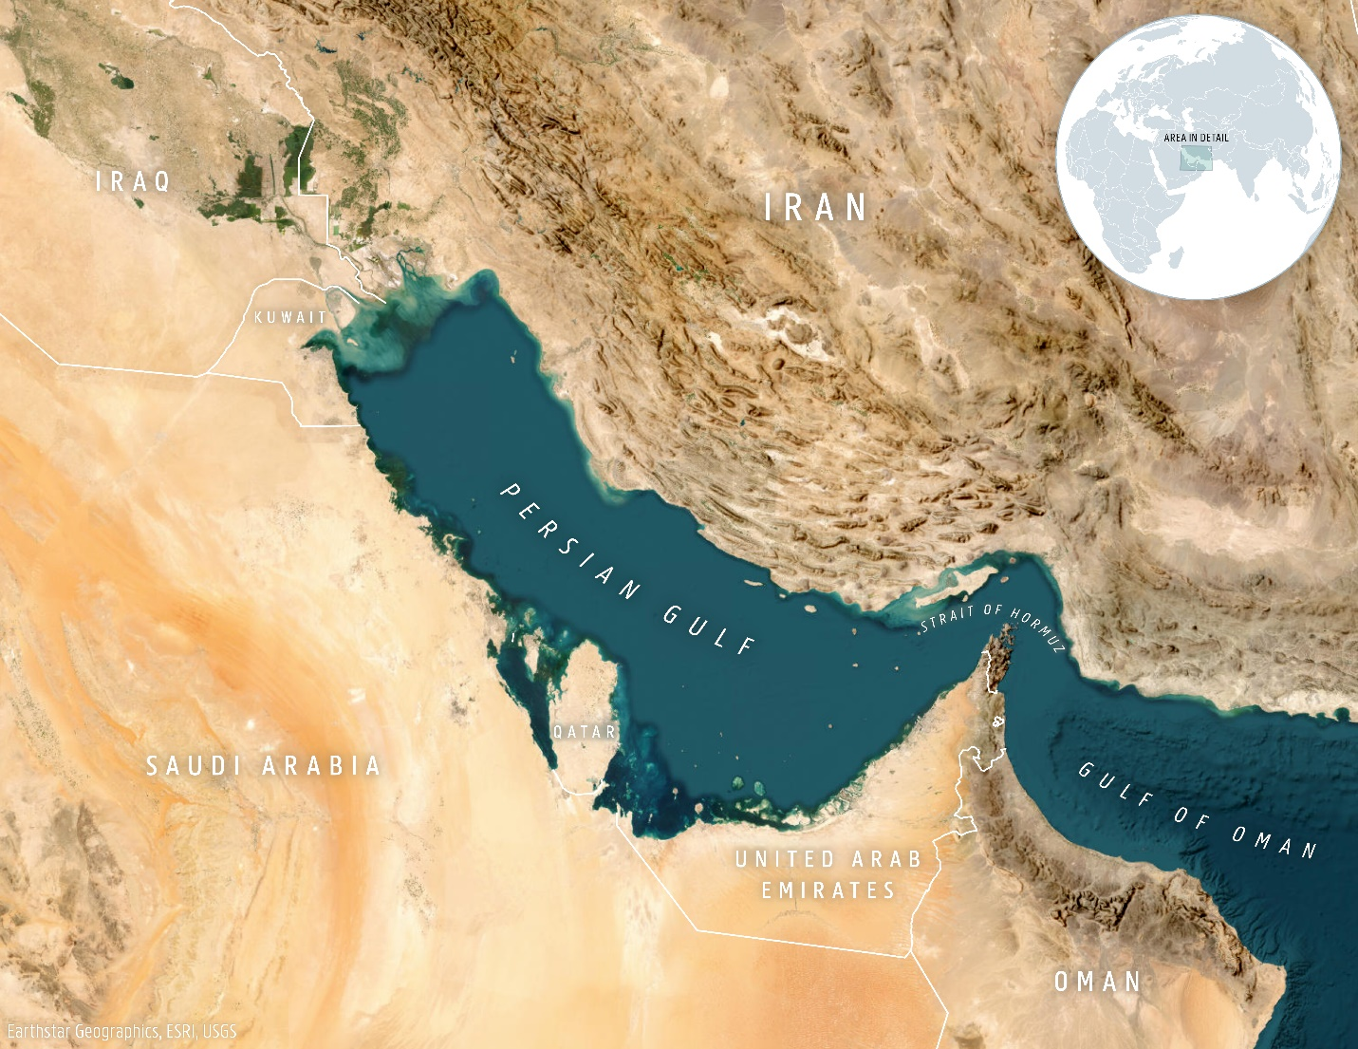
Sources: BTS and Large Scale International Boundaries Office of the Geographer and Global Issues at the U.S. Department of State, February 2025.

The majority (61 percent) of vessels transiting the Strait are tankers, followed by dry bulk (17 percent), and containerships (15.5 percent). The top three commodities through the Straight are mineral products, chemical products, and vegetable products (IMF, 2025).
In 2025, the Strait is on track to have the smallest amount of cargo throughput compared to 2022 to 2024. The trade volume in 2025 (as of September 2025) was lower than the same time period in 2024 by 10 percent, in 2023 by 12 percent, and in 2022 by 14 percent. Overall, there is a seasonal trend, with lows in December through February. (Figure 3). In addition, February 2025 had the smallest monthly amount of cargo, followed by September 2025 and then January 2025.
Figure 2. Monthly Trade Volume (short tons), January 2022 through September 2025

Source: U.S. Department of Transportation, Bureau of Transportation Statistics, based upon data from the International Monetary Fund. 2025PortWatch. Strait of Hormuz. Accessed October 21, 2025. https://portwatch.imf.org/pages/port-monitor.

While the provided tonnage data is not disaggregated by commodity type, the number of transits is provided for tankers and cargo ships. The number of tanker transits appears seasonal, with highs in late Spring through Summer, and lows in December through February (Figure 2). However, in 2025, the number of transits was overall lower than those in previous years, with the total for January through September 2o25 being 10 percent less than the same time period in 2024, 12 percent less than in 2023, and 13 percent less than in 2022 The month with the smallest number of tanker transits was February 2025, followed by February 2024 and then September 2025.
The number of cargo ship transits also appears seasonal, with highs in Spring through early Fall and lows in December through February. In 2025, the number of transits was overall higher than those in previous years, with the total for January through September 2025 being 1 percent greater than the same time in 2024, 4 percent greater than in 2023, and 12 percent greater than in 2022. Thus, the number of cargo ships is moving in a different direction than the number of tankers. The highest number of cargo ships transits was in April 2025, followed by May 2025, and then June 2025, while the lowest number was in January 2022, followed by February 2024, and then February 2025.
Thus, the trends in cargo movement are more aligned with tanker transits than cargo transits.
Figure 3. Monthly Number of Transits by Vessel Type, January 2022 through September 2025

Source: U.S. Department of Transportation, Bureau of Transportation Statistics, based upon data from the International Monetary Fund. 2025PortWatch. Strait of Hormuz. Accessed October 21, 2025. https://portwatch.imf.org/pages/port-monitor.

For the United States, imports via Persian Gulf ports have been declining overall (Figure 4 ). In 2025, imports were overall lower than in previous years, with the total for January through June 2025 10 percent lower than the same period in 2024, 22 percent lower than in 2023, and 24 percent lower than in 2022. The month with the fewest imports was February 2024, followed by December 2024, April 2025, February 2025, and June 2025.
Figure 4. U.S. Import Tonnage from Persian Gulf Ports via Vessels, January 2022 through June 2025

Source: U.S. Department of Transportation, Bureau of Transportation Statistics, based upon U.S. Department of Commerce, Census Bureau, USA Trade Online, available at www.census.gov as of August 2025.

References
Brown, P., O'Rourke, R., Ratner, M., Rosen, L. W., & Thomas, C. (2025). Iran Conflict and the Strait of Hormuz, Oil and Gas Market Impacts. Washington, D.C.: Library of Congress.
IMF. (2025, October 21). PortWatch. Retrieved from Strait of Hormuz: https://portwatch.imf.org/
Navigation and Civil Works Decision Support Center. (2021). The U.S. Coastal and Inland Navigation System 2021 Transportation Facts & Information. U.S. Army Corps of Engineers.
U.S. Energy Information Administration. (2012, January 4). The Straight of Hormuz is the world's most important oil transit chokepoint. Retrieved October 22, 2025, from https://www.eia.gov/todayinenergy/detail.php?id=4430

Saudi Arabia has ports both on the Persian Gulf and the Red Sea. Persian Gulf ports accounted for 77 percent of exports and Red Sea ports accounted for 23 percent of exports in November 2024 through October 2025.

